Assignment-3

|  |  |
| --- | --- |
| Assignment Date | 20 october2022 |
| Student Name | HARI KRISHNA M |
| Student Roll Number | 1901044 |
| Maximum Marks | 2 Marks |

Question-1:

1. Create a Bucket in IBM object storage.

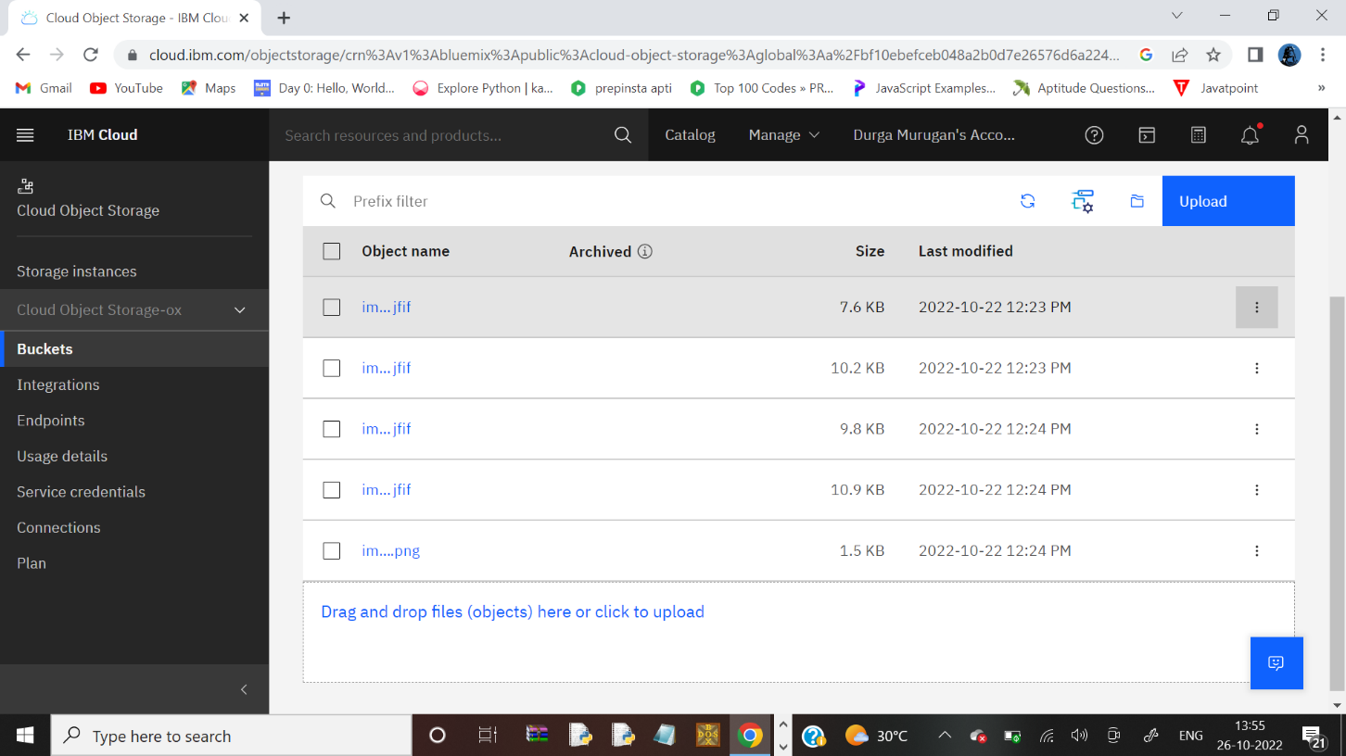

Question-2:

1. Upload an 5 images to ibm object storage and make it public. write html code to displaying all the 5 images.

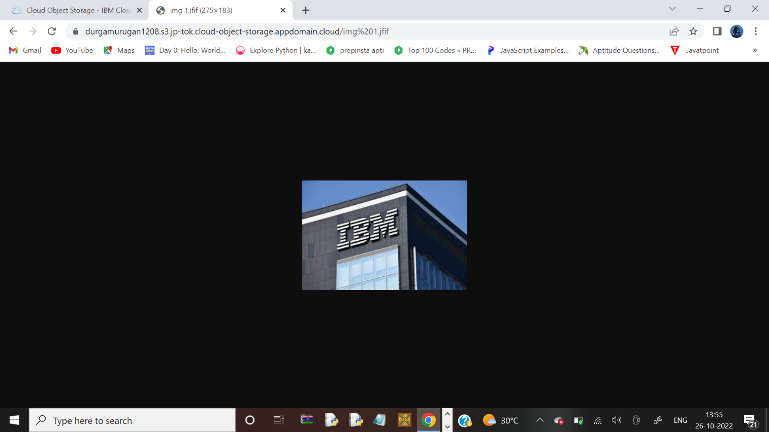

<!DOCTYPE html>

<html>

<title>company logo's</title>

<head>

<style> img{ display: block; margin-left: auto; margin-right: auto; border: aqua;

width: 50%;

}

</style>

</head>

<body style="background-color: white;">

<h1>CLOUD COMPUTING COMAPANIES</h1>

<img src=" https://annarshankar1901013.s3.jp-tok.cloud-object-storage.appdomain.cloud/mount1.jpg img%201.jfif" alt="ibm" style="width:65%" >

<br>

<img src="https://annarshankar1901013.s3.jp-tok.cloud-object-storage.appdomain.cloud/mount2.jpg/img%202.jfif" alt="ibm1" width="600"

height="600" style="width:50%>

<br>

<img src="https://annarshankar1901013.s3.jp-tok.cloud-object-storage.appdomain.cloud/mount3.jpg/img%202.jfif" alt="ibm2" width="600" height="600" style="width:50%">

<br>

<img src="https://annarshankar1901013.s3.jp-tok.cloud-object-storage.appdomain.cloud/mount4.jpg/imgg%204.png" alt="ibm3" width="600" height="600">

<br>

<img src="https://annarshankar1901013.s3.jp-tok.cloud-object-storage.appdomain.cloud/mount5.jpg/img%205.jfif" alt="ibm4" width="600" height="600">

</body>

</html>

Question-3:

Upload a css page to the object storage and use the same page in your HTML code.

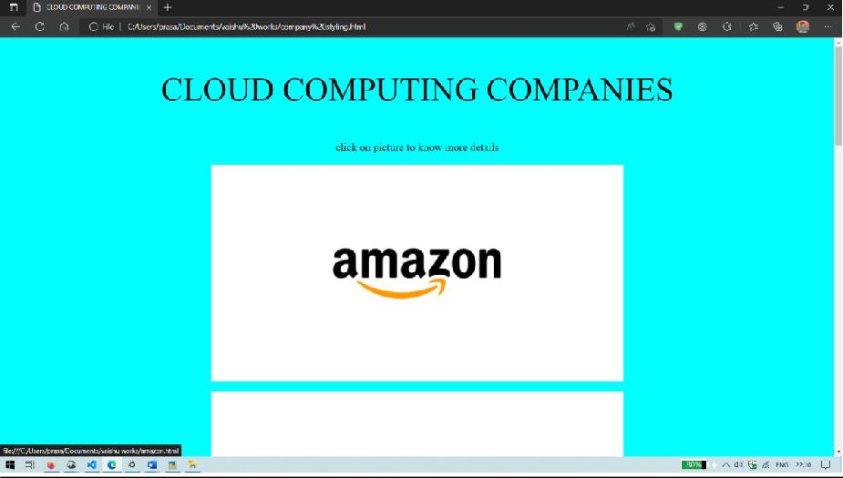

**company styling.html:**

<!DOCTYPE html>

<title>CLOUD COMPUTING COMPANIES</title>

<head>

<style> img{ display: block;

margin-left: auto; margin-right: auto; border: aqua; width: 50%;

}

</style>

</head>

<body style="background-color: aqua;">

<p style="text-align: center;font-weight: 300; font-size:60px;" >CLOUD COMPUTING COMPANIES</p>

<p style="text-align: center;font-size: 20px;">click on picture to know more details</p>

<a href=”amazon.html>

<imgsrc="[http://s3.jp-tok.cloud-object-](http://s3.jp-tok.cloud-object-/) storage.appdomain.cloud/storagebucketannarshankar1901013/amazon.png"alt="amazon" style="width:50%"> </a>

<br>

<a href="google.html">

<img src=["http://s3.jp-tok.cloud-object-](http://s3.jp-tok.cloud-object-/) storage.appdomain.cloud/storagebucketannarshankar1901013/google.webp" alt=" google"width="600" height="600">

</a>

<br>

<a href="ibm.html">

<imgsrc="<http://s3.jp>[-tok.cloud-object](http://s3.jp-tok.cloud-object-/)storage.appdomain.cloud/storagebucketDurga/ibm.jpg"alt="ibm"width="600" height="600"> </a>

<br>

<a href="box.html">

<img src=["http://s3.jp-tok.cloud-object-storage.appdomain.cloud/storagebucketannarshankar1901013/box.jpg](http://s3.jp-tok.cloud-object-storage.appdomain.cloud/storagebucketvaishu/box.jpg) " alt="box" width="600" height="600">

</a>

<br>

<a href=microsoft.html>

<img src=["http://s3.jp-tok.cloud-object](http://s3.jp-tok.cloud-object-/)storage.appdomain.cloud/storagebucketannarshankar1901013/microsoft.webp " alt="microsoft"width="600" height="600"> </a>

</body>

</html>

# Style.css

Body{

style="border:rgb(15, 15, 15);

border-width:5px; border-style:double;text-align: center;font-family: Arial, Helvetica, sans-serif;

background-color:powderblue"

}

# Ibm.html

<html>

<head>

<title>ibm</title>

</head>

<body style="border:rgb(15, 15, 15); border-width:5px; border-style:double;text-align:

center;font-family: Arial, Helvetica, sans-serif;background-color:powderblue">

<h1 style="border:rgb(15, 15, 15); border-width:5px; border-style:solid;text-align: center;font- family: Arial, Helvetica, sans-serif;"> IBM</h1>

<p style="border:black; border-width:5px; border-style:hidden;text-align: center;font-family:

Arial, Helvetica, sans-serif;padding: 2px;">

IBM offers three hardware platforms for cloud computing.[1] These platforms offer built-in

support for virtualization. IBM also offers a virtualization application infrastructure, Websphere, which supports programming models and open standards for virtualization.

The management layer of the IBM cloud framework includes IBM Tivoli middleware.[2] Management tools provide capabilities to regulate images with automated provisioning and de- provisioning, monitor operations and meter usage while tracking costs and allocating billing. The last layer of the framework provides integrated workload tools.[3] Workloads (in the context of cloud computing) are services or instances of code that can be executed to meet specific business needs.[4] IBM also offers tools for cloud based collaboration, development and testing, application development, analytics, business-to-business integration, and security.[5]

</p>

<p style="text-align:center;"> <img src=["http://s3.jp-tok.cloud-object-](http://s3.jp-tok.cloud-object-/) storage.appdomain.cloud/storagebucketvaishu/ibm.jpg" alt="ibm" width="40%"height=45%></p>

<a href='company styling.html' target='_self'>

<button style=" margin: 2px;border:black;float:left ;background-color:powderblue;border-radius:

2px;border-style:solid ;font-family:'Times New Roman', Times, serif;font-size:

medium;">back</button>

</a>

</body>

</html> Question-4:

Design a chatbot using IBM Watson assistant for hospital. Ex: User comes with query to know the branches for that hospital in your city. Submit the web URL of that chat bot as a assignment.

https://web-

chat.global.assistant.watson.appdomain.cloud/preview.html?backgroundImageURL=https%3A%

2F%2Fus-south.assistant.watson.cloud.ibm.com%2Fpublic%2Fimages%2Fupx-3ca7b843-00ec- 42bb-aec4-9a506bb2ba9d%3A%3A12b68964-95d4-4c80-aa84-

29986b643977&integrationID=35639d76-93bb-4dd0-be50-3fa546c6ed51&region=us-

south&serviceInstanceID=3ca7b843-00ec-42bb-aec4-9a506bb2ba9d

[Watson Assistant Preview (appdomain.cloud)](https://web-chat.global.assistant.watson.appdomain.cloud/preview.html?backgroundImageURL=https%3A%2F%2Fus-south.assistant.watson.cloud.ibm.com%2Fpublic%2Fimages%2Fupx-3ca7b843-00ec-42bb-aec4-9a506bb2ba9d%3A%3A12b68964-95d4-4c80-aa84-29986b643977&integrationID=35539d76-93bb-4dd0-be50-3fa546c6ed51&region=us-south&serviceInstanceID=3ca7b843-00ec-42bb-aec4-9a506bb2ba9d)

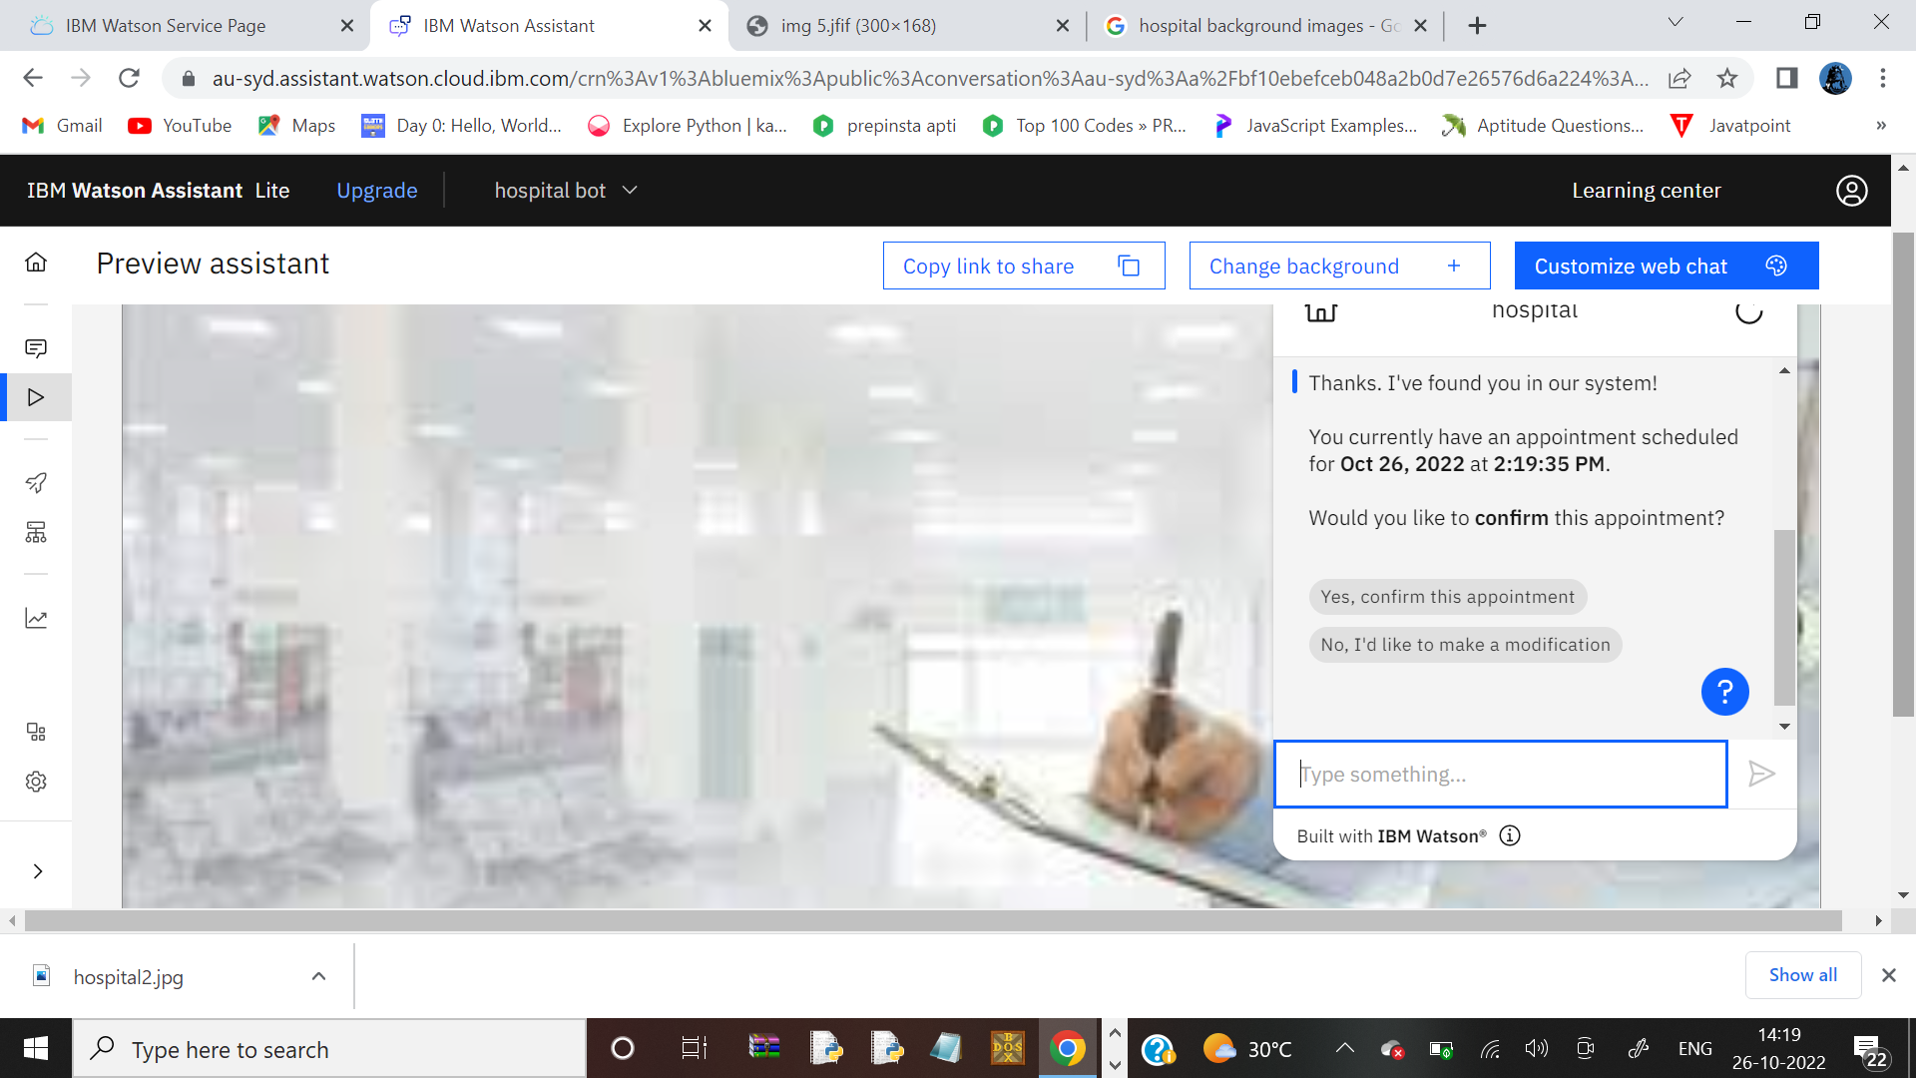

5.Create Watson assistant service with 10 steps and use 3 conditions in it. Load that script in

HTMLpage.

<!DOCTYPE html>

<title>abc hospital</title>

<style> body { background: url(https://wallpaperaccess.com/full/1282794.jpg) no-repeat center center fixed; -webkit-background-size: cover;

-moz-background-size: cover; -o-background-size: cover; background-size: cover

}

</style>

<body>

<script>

window.watsonAssistantChatOptions = {

integrationID: "cf7b4f9f-8609-4df6-9ded-d9b707946240", // The ID of this integration.

region: "au-syd", // The region your integration is hosted in.

serviceInstanceID: "064142e0-0c44-419d-9a62-6abbe12e69cc", // The ID of your service instance.

onLoad: function(instance) { instance.render(); }

};

setTimeout(function(){

const t=document.createElement('script');

t.src="https://web-chat.global.assistant.watson.appdomain.cloud/versions/" + (window.watsonAssistantChatOptions.clientVersion || 'latest') + "/WatsonAssistantChatEntry.js";

document.head.appendChild(t);

});

</script>

</body>

</html>

